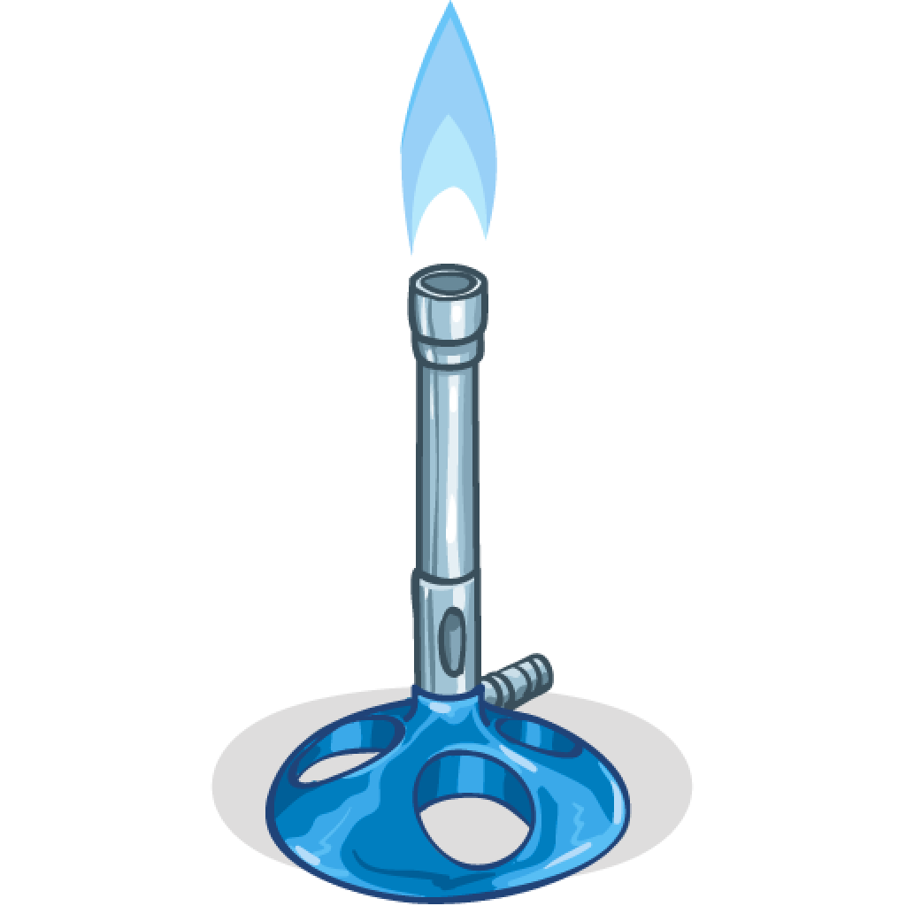

***Bunsen Burner Licence***

*This certifies that*

*..........................................................................  
is able to carry out the following:*

* *Name the different parts of the Bunsen Burner*
* *Set up a Bunsen Burner correctly*
* *Light a Bunsen Burner correctly*
* *Use a Bunsen Burner safely and adjust the heat of the flame*

*Signed: Date:*

*\*Licence is immediately revoked if the above conditions are not followed.*

***Bunsen Burner Licence***

*This certifies that*

*..........................................................................  
is able to carry out the following:*

* *Name the different parts of the Bunsen Burner*
* *Set up a Bunsen Burner correctly*
* *Light a Bunsen Burner correctly*
* *Use a Bunsen Burner safely and adjust the heat of the flame*

*Signed: Date:*

*\*Licence is immediately revoked if the above conditions are not followed.*